Report on Project Design Phase 1

**Personal Assistance For Seniors Who Are**

**Self Reliant**

**Problem Statement:**

Nowadays, most families are spending time on their work and social activities so, they cannot able to spend time with senior citizens. This can lead to loneliness in seniors. Reducing Physical health and increasing dependency can put seniors under constant pressure. Many seniors, who suffer from arthritis also suffer from depression. Arthritis is a disease that can lead to a loss of mobility, which in turn can lead to a loss of a feeling of independence. IoT aims at developing smart devices to support elderly people both in their own houses and in retirement homes. Our proposed system is Arduino-based home automation with Arduino connected to a Wi-Fi and controlled via Android Application. It provides security, safe and helpful for senior citizens who are unable to move from one place to another place and it provides a better life quality to the elderly use.

**Solution description:**

In our project, we are going to address the above mentioned issues, due to arthritis disease, senior citizens can not able to move from one place to another place. They cannot turn ON or OFF home appliances directly. For this reason, we are going to build a smart home device that can be used to control home appliances via the internet. The home appliances are connected to a power supply, which is controlled by an android device. IoT technology is used to connect the software and hardware The wifi module is provided with a power supply connected to Arduino. The device and the wifi module are connected through the cloud where the information is stored. This helps senior citizens to

ON or OFF their home appliances, without getting out of bed. The Mobile application is Created and programmed with Arduino UNO. With the help of the internet, the condition ON/OFF is given, and it is operated by Arduino UNO. When the instruction is given as ON/OFF, the appliances connected to Arduino via wifi help to make changes in the appliances.

**Novelty :**

In earlier days, senior citizens lived in the traditional home that cannot have any advanced technologies. if they want to switch on the light, they have to move from their bed. That was very difficult for them to meet their daily needs. but due to the inclusion of this technology, in-home senior citizens will be able to control their home appliances with a single click. Besides that this helps them to save energy. As this project will be based on IoT the senior citizens will be able to control their home appliances from their place itself. The whole process can also be automated so that the process can be fast.

**Social Impact:**

As the project is going to be IoT based, it is undeniably beneficial for saving energy, reducing costs, and boosting efficiency. The senior citizens will be able to feel independent. The components used in this process will be cost-effective and will consume only less power. The senior citizens will be able to control the home appliances with a single click from their place itself and the actions will be quick. This inclusion of technology will make the work simpler and it will pave way for the development of home sector.

**Business Model :**

We are going to make some campaigns and check how many of them are interested to take this Product. The main components used are very cost-

effective and also the number of components will vary depending on the size of the home. As the whole process is controlled by technology, senior citizens are leading to happier and healthier cared-for individuals. This will promote safe independent living. As senior citizens will be able to control the home appliances at right time, they will be able to reduce the power loss and avoid the cost of repair.

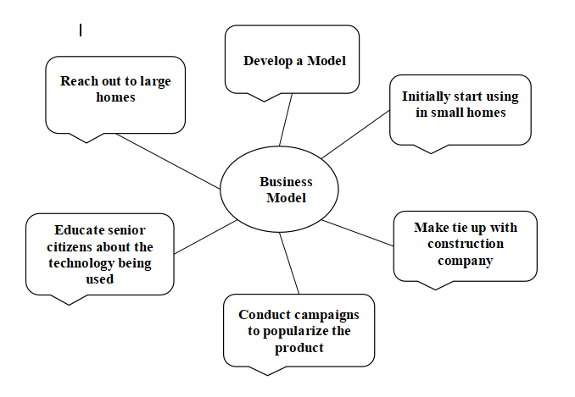

**Scalability of solution:**

This project is very much efficient because it is based on IoT for low-cost and flexible home control and a Monitoring System using an Android-based Smartphone . The techniques which are going to use in home automation include those in building automation as well as the control of domestic activities such as TV, fan, and electric tube light. So the senior Citizens will be able to control everything From their place itself. it acts according to

inhabitant requirements. we are planning to eliminate most of the human interaction by providing an intelligent system. development of such smart homes achieves by the Internet of Things technologies. By using this system, we can manage to make low-cost, Flexible smart homes to resolve their errors with energy saving.